**R4M8A08 8-channel RS485 MOSFET controller Manual**

* [2CH RS485 Relay Serial HyperTerminal Enter](http://v.youku.com/v_show/id_XMTM0ODY4NzkxMg==.html):

**http://v.youku.com/v_show/id_XMTM0ODY4NzkxMg==.html**

* [2CH RS485 Relay Modbus Poll Enter](http://v.youku.com/v_show/id_XMTM0ODY4OTg5Mg==.html)(Usage 2-channel and 8-channel is the same):

**http://v.youku.com/v_show/id_XMTM0ODY4OTg5Mg==.html**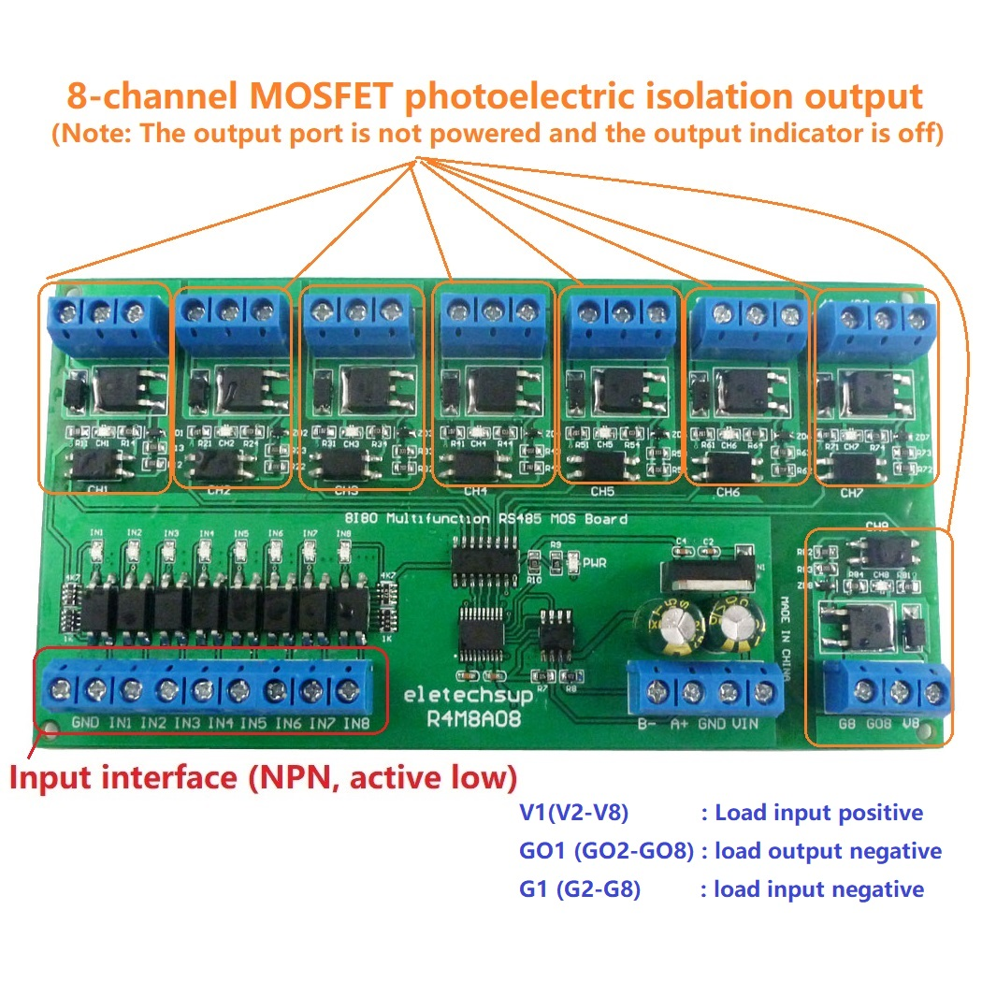

**Features:**

1 Working voltage: DC12V (Range 6-25V)

2 Working current: 8-10MA(12V)

3 8 photoelectric isolation Input ports (NPN low level active ), the input and output relationship can be set to associated (default) and non-associated through commands.

4 8 photoelectric isolated output ports, "open" "close" "Momentary" "Self-locking" "Interlock" "Delay" 6 Commands

5 MODBUS RTU Command, Support 03 06 16 function code

6 Under the "Delay" Command ,the maximum delay is 255 seconds;

7 MODBUS Commands can be made serial HyperTerminal (serial assistant) OR "Modbus Poll" Enter;

8 Under the MODBUS command mode, it can support up to 64 devices in parallel

9 The default baud rate is 9600BPS. The baud rate can be selected through jumpers: 2400 4800 9600 19200BPS

10 Size: 136 * 72 * 18mm(Only PCB Board);140 * 88* 40mm(with Din Rail Box)

11 Weight:75g(Only PCB Board);175g(with Din Rail Box)

12 MOSFET load: 3.5-5V is 2A; 5-9V is 4A; 9-30V is 5A

The MOSFET model is 20N06, and each output channel is an independent control unit, which does not interfere with each other. If one MOSFET is burnt out and it does not affect the work of other channels, just replace the MOSFET with a new one.

**The advantages and disadvantages relative to the relay board:**

Advantages: 1 small working current, 8-10MA (12V); 2 no sound when switching states; 3 light weight

Disadvantages: 1 load current is small, within 5A; 2 can only control DC 3.5-30V voltage

V1(V2-V8): Load input positive

GO1 (GO2-GO8): load output negative

G1 (G2-G8): load input negative

Note: The output indicator(CH1/2...8 LEDs) is only valid when there is load power

DIN rail Box parameters:

Product model: UM72

Color: green

Width: suitable for PCB board width UM72(72mm)

Insulation grade: flame-retardant VO grade

Backplane length: suitable for 136 mm PCB boards

Net weight:100g

Installation: DIN35 and C45 rail

**Typical applications:**

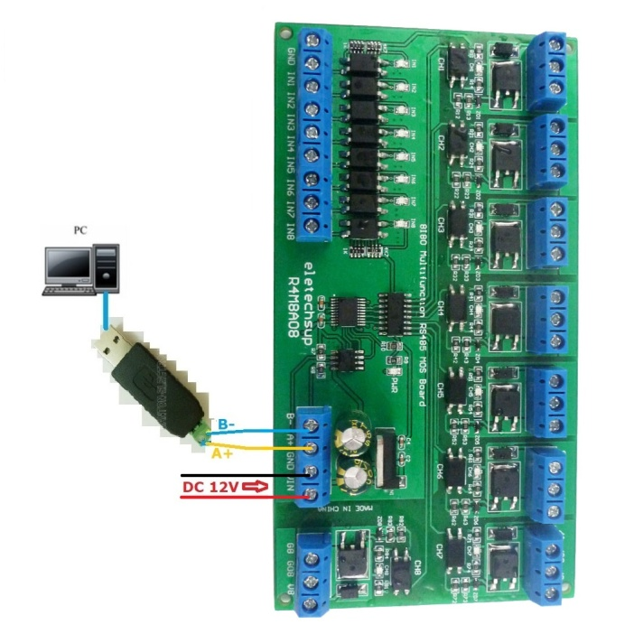

1 The dial switch (slave address) is invalid and can only control one module at a time.

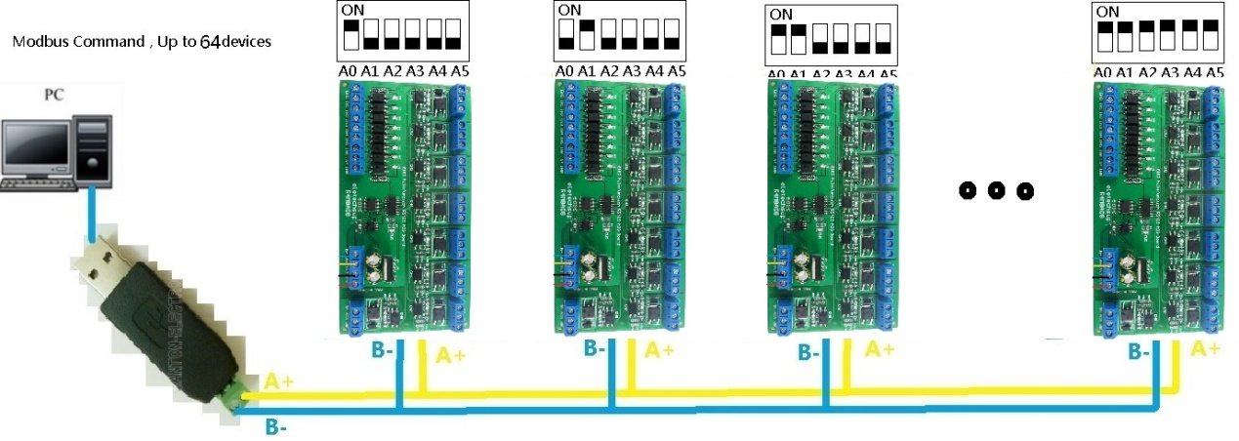

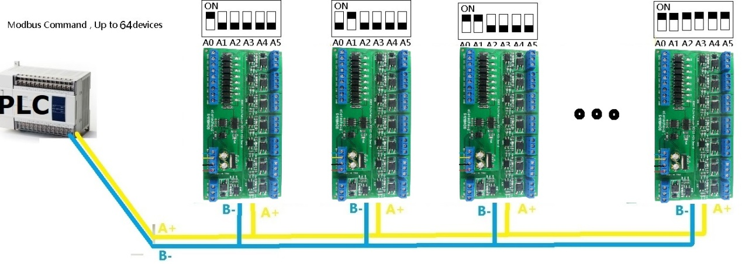

MODBUS command mode (HEX), you can control a variety of ways: Serial Hyper Terminal Control (need to manually add the CRC), Modbus Poll software control (software automatically add the CRC), PLC or MCU process control

**Wiring Diagram:**

The power supply is DC 6-25V, the load is DC 3.5-30V circuit, the wiring is as shown in the figure below. The load "LOAD" can be high-power relays, LED lights, fans, motors, cameras and other DC 3.5-30V equipment

